Week of Oct. 10-14, 2016 “Together We SOAR!” in Second Grade

Story for this Week: The Bremen Town Musicians Genre: Folktale
Skills that will be assessed on Friday:
- High frequency Words to learn to read instantly: bought, people, pleasant, probably, scared, shall, sign
- Reading Comprehension: Cause and Effect and Story Structure
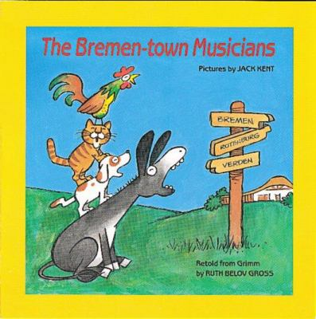
- Grammar: Contractions
Report cards will come home next Monday, Oct. 17
- Writing: Narratives (stories about ourselves)
- Phonics and Spelling: ar, or (the “bossy r”)
- Fluency: Read with Expression
Math: Beginning Mental Math Addition Strategies
Science: Beginning Matter/Solids and Liquids

***Homework is subject to change at teacher’s discretion. We appreciate students getting here at 7:45 in order to eat their breakfast in a timely manner. Thank you parents! Also, remember that the Spelling score/grade includes DAILY spelling practice…NOT just the Friday’s spelling test. Students must apply appropriate spelling in order to know that they’ve mastered required words, not just on Friday’s test day.

Monday’s Homework
****Spelling: (r-Controlled ar, or, ore) Write each word three times. Circle the letter partners in each word.
1. part 4. horse 7. smart 10. corn 13. dart
2. hard 5. before 8. farm 11. chore 14. sister
3. born 6. more 9. porch 12. score 15. morning

***Challenge: therefore, cardinal, parties, barber, tornado

We also are requiring the students to write at least 2 sentences dictated to them on our spelling tests.
**Read all or part of your new story “The Bremen Town Musicians”.

Tuesday’s Homework
**Math: A worksheet or workbook page will come home.
**Read your story “The Bremen Town Musicians” again.
**Spelling: Put the first 15 words in ABC order. Use your best handwriting.

Wednesday’s Homework
**Grammar: Contractions….Do page _197_in your textbook. (top—Write sentences, bottom—write contractions AND the two words that mean the same—NOT the sentences)
**Read the fable AFTER your story.
**Study your spelling words---spell them out loud to someone at home.
**Math: Copy these numbers and write and spell their words correctly: 10, 20, 30, 40, 50, 60, 70, 80, 90, 100

Thursday’s Homework
**Math: Worksheet will come home.
**Spelling: Study for your test!

